**Uncollected or Lost Children**

Abacus’s aim is to ensure all children are always safe and secure. We aim to ensure all children are collected at the correct time by the correct parent or carer and have robust procedures in place if this does not happen.

It is the responsibility of the Parent or Carer to ensure that the contact details on the Child Record Sheet held at Pre-School are kept up to date.

Parents / carers will be asked annually to ensure these details are kept up to date:

1. Home address,
2. Telephone number and/or mobile telephone number,
3. Place of work and alternative telephone numbers
4. Names, addresses and contact number of alternative adults authorised to collect the child.

5. Information about any person who does not have legal access to the child

6. Information about who has parental responsibility for the uncollected child

If a parent / carer cannot collect their child, they must write down the name and telephone number of the person who will be collecting the child, including a password to be provided on collection, and hand this to the Manager (or ring to give these details).

* We expect children will be picked up at the correct time. If this does not happen, we must assume an emergency has caused the delay and will instigate our procedure, unless a parent/carer contacts us to inform us they will be delayed
* Children who are not collected within thirty minutes of the correct time will become the responsibility of the Kingston Social Services Department. In this case, the Manager will call the parents on given contact numbers. If no one is available on those numbers, the Manager will contact the additional emergency contact numbers. If no one is available on that number, the Manager must call the Social Services and request collection of the child; Ofsted will be notified. At all times, two members of staff will be present and they and the child will remain in the setting until Social Services collect the child.

**Lost Children**:

In the event of a missing child, the Flowchart must be followed and information available for the emergency services.

* Address of the Setting (including telephone number/main contact)
* Child details including age, sex, description of physical characteristics, what they were wearing
* The next of kin for the child and any contact number (found on the child information sheet)
* Does the child have anything with them or removed anything i.e. their bag
* The circumstances of the incident i.e. location last seen, how long they have been missing, last time headcount was taken
* Was there anything we were aware of that could have triggered the disappearance (i.e. argument (older child), family disputes (absent parents)
* Who is looking for the child, where are they, do they have a mobile with them, what is the number?

Missing Child Flowchart

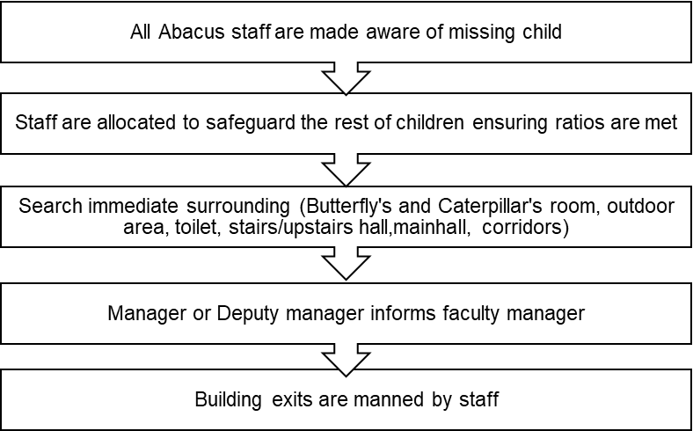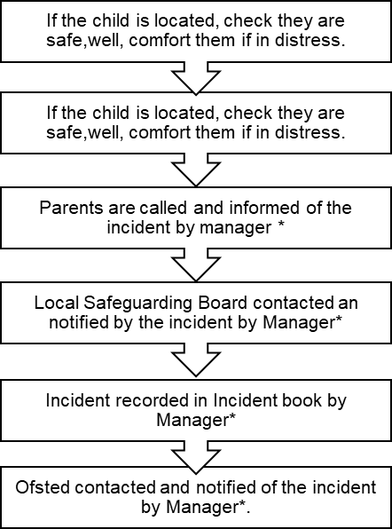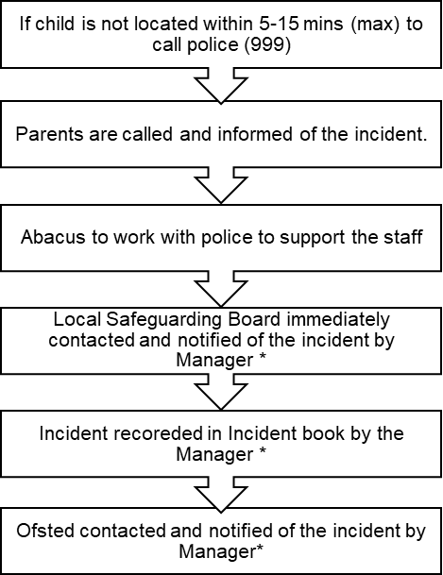

*Where Manager is unable to make the relevant calls, the Deputy Manager could assist

**Date Reviewed**: May 2021

**Next Review Date**: May 2022